C64 CHARSET-Adaptor/Switch Rev. 0

Module Description

# Introduction

The board serves for adapting the CHARACTER ROM U5 (type 2332) to a 27C512 (or 27C256, 27C128, 27C64) EPROM. The pin out of both ICs are slightly different and need adaptation. Furthermore, it allows to access (up to 16) different character sets, which can be selected via the pin-header on the module.

The CHARSET-Adaptor/Switch is suitable to work together with the Keyboard Controlled Kernal Switch (Project Number 128).

This pin-header is connected in a way, that the selection can either be accomplished with standard 2.54mm jumper bridges, DIP-switches, hex-encoding switches or a microcontroller like an Arduino etc.

|  |  |  |  |
| --- | --- | --- | --- |
| **Signal** | **Pin** | **Pin** | **Signal** |
| A12 | 1 | 2 | GND |
| A13 | 3 | 4 | GND |
| A14 | 5 | 6 | GND |
| A15 | 7 | 8 | GND |
| +5V | 9 | 10 | +5V |

Table 1: Jumper (JP1) for Bank Selection

The +5V pins are to provide supply voltage to a microcontroller.

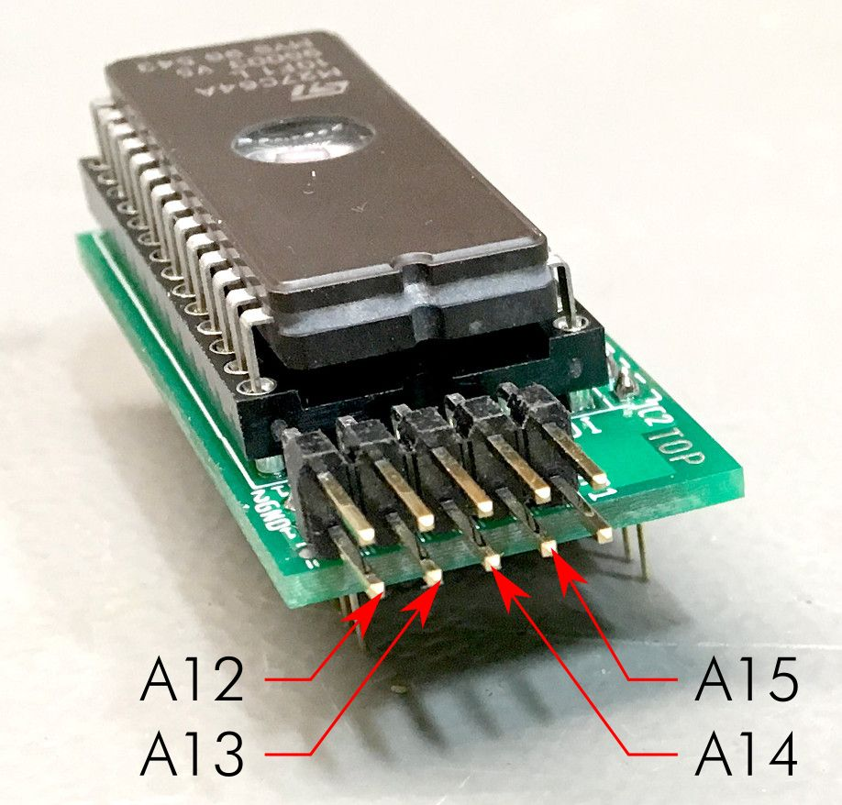

Figure 1: Address pins of JP1

# Bank Selection

The desired CHARACTER SET is selected at JP1. For the pinout refer to Table 1. The jumper is installed (vertically) in a way, that it connects the address line with the GND potential.

| A15 | A14 | A13 | A12 | 4k Block | | Addr. Offset |
| --- | --- | --- | --- | --- | --- | --- |
| set | set | set | set | | #0 | 0x0000 |
| set | set | set | open | | #1 | 0x1000 |
| set | set | open | set | | #2 | 0x2000 |
| set | set | open | open | | #3 | 0x3000 |
| set | open | set | set | | #4 | 0x4000 |
| set | open | set | open | | #5 | 0x5000 |
| set | open | open | set | | #6 | 0x6000 |
| set | open | open | open | | #7 | 0x7000 |
| open | set | set | set | | #8 | 0x8000 |
| open | set | set | open | | #9 | 0x9000 |
| open | set | open | set | | #10 | 0xA000 |
| open | set | open | open | | #11 | 0xB000 |
| open | open | set | set | | #12 | 0xC000 |
| open | open | set | open | | #13 | 0xD000 |
| open | open | open | set | | #14 | 0xE000 |
| open | open | open | open | | #15 | 0xF000 |

Table 2: Selection of EPROM memory blocks

A set jumper corresponds to a LOW level (binary 0), an open jumper to a HIGH level. Do not confuse the C64 memory address and the EPROM memory address. They have the address Bit A0 to A11 in common, but the rest is different. Each of the 4k blocks appears between address $D000 and $DFFF of the C64.

# Dimensions

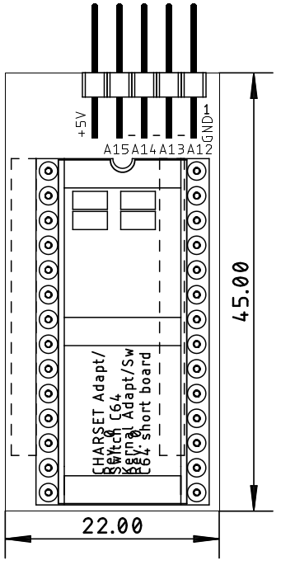

Figure 2: Dimensions of the Character ROM Adaptor/Switch

# Compatibility of EPROMs

Although a 27C512 type EPROM is recommended, other types of EPROMs can be installed:

|  |  |  |
| --- | --- | --- |
| EPROM | Size | Capacity |
| 27C64 | 8k | 2x Character Sets |
| 27C128 | 16k | 4x Character Sets |
| 27C256 | 32k | 8x Character Sets |
| 27C512 | 64k | 16x Character Sets |

Table 3: Capacity of EPROM types

Those EPROMs are pin compatible, the jumpers, that have no function, due to the size, have to stay open.

|  |  |  |  |  |  |
| --- | --- | --- | --- | --- | --- |
| EPROM | Size | A15 | A14 | A13 | A12 |
| 27C512 | 64kx8 | 🗹 | 🗹 | 🗹 | 🗹 |
| 27C256 | 32kx8 | open | 🗹 | 🗹 | 🗹 |
| 27C128 | 16kx8 | open | open | 🗹 | 🗹 |
| 27C64 | 8kx8 | open | open | open | 🗹 |

Table 4: Settings per EPROM type

🗹: The jumper can be open or closed, depending on the desired selection.

In case Vpp is located at a dedicated pin (pin 1), A15 has no effect anymore. A HIGH level is recommended, the corresponding jumper is open. The /PGM Pin should be set HIGH, this is accomplished by an open jumper for A14.

|  |  |  |  |  |  |  |  |  |  |  |  |
| --- | --- | --- | --- | --- | --- | --- | --- | --- | --- | --- | --- |
| 27C64 | | | | | | | | | | | |
|  | 27C128 | | | | | | | | | |  |
|  | 27C256 | | | | | | | |  |
|  | 27C512 | | | | | |  |
|  | SOCKET | | | |  |
| Vpp | Vpp | Vpp | A15 | 1 | A15 | VCC | 28 | VCC | VCC | VCC | VCC |
| A12 | A12 | A12 | A12 | 2 | A12 | A14 | 27 | A14 | A14 | /PGM | /PGM |
| A7 | A7 | A7 | A7 | 3 | A7 | A13 | 26 | A13 | A13 | A13 | n.c. |
| A6 | A6 | A6 | A6 | 4 | A6 | A8 | 25 | A8 | A8 | A8 | A8 |
| A5 | A5 | A5 | A5 | 5 | A5 | A9 | 24 | A9 | A9 | A9 | A9 |
| A4 | A4 | A4 | A4 | 6 | A4 | A11 | 23 | A11 | A11 | A11 | A11 |
| A3 | A3 | A3 | A3 | 7 | A3 | /OE | 22 | /G/Vpp | /G | /G | /G |
| A2 | A2 | A2 | A2 | 8 | A2 | A10 | 21 | A10 | A10 | A10 | A10 |
| A1 | A1 | A1 | A1 | 9 | A1 | GND | 20 | /E | /E | /E | /E |
| A0 | A0 | A0 | A0 | 10 | A0 | D7 | 19 | D7 | D7 | D7 | D7 |
| D0 | D0 | D0 | D0 | 11 | D0 | D6 | 18 | D6 | D6 | D6 | D6 |
| D1 | D1 | D1 | D1 | 12 | D1 | D5 | 17 | D5 | D5 | D5 | D5 |
| D2 | D2 | D2 | D2 | 13 | D2 | D4 | 16 | D4 | D4 | D4 | D4 |
| GND | GND | GND | GND | 14 | GND | D3 | 15 | D3 | D3 | D3 | D3 |

Table 5: EPROM pin compatibility

# Programming instructions

Character sets can be found here:

<http://www.zimmers.net/anonftp/pub/cbm/firmware/computers/c64/index.html> or elsewhere. For instructions on setting up a complete multiple character ROM image, please refer to

<https://github.com/svenpetersen1965/C64-Kernal-Adapter-Switch-Long-Board/blob/master/Rev.%200/pdf/C64_KernalSw_8k_v0.pdf>

The description is about how to create a multiple Kernal ROM image, a multiple Character ROM image works pretty similar, except the size is only 4kB.

# Revision History

## Rev. 0

Prototype, fully functional.